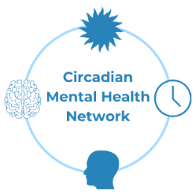
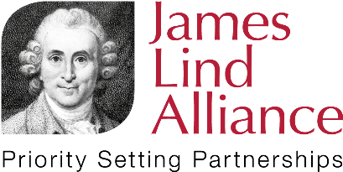
Mental Health and the Body Clock
Have your say
Taking part in this survey is entirely your choice. You can leave the survey at any stage. Your answers will be anonymous and we will not be able to identify you.
This survey is only for young people and adults living in the UK (from age 11 upwards). This is because we are unable to address questions based around the different situations/services/ guidelines outside of the UK, and because some of the questions may not be relevant to young children.
If you need help completing this survey, you are welcome to ask a parent, guardian, or carer to help you. If you are aged 11-17 years old, we would encourage you to let a parent or guardian know that you are interested in this survey.
Has a disrupted body clock impacted your mental health? Or has your mental health impacted your body clock? What questions would you like answered concerning mental health and the body clock?
Your questions will help inform what future research should be focused on. Your questions will help to shape research to benefit as many people as possible.
Who are we?
The Circadian Mental Health Network is looking to understand the relationships between mental health and the body clock.
This survey was put together by our Steering Group, which includes researchers, clinicians, support charity members and people with lived experience. We want to know what matters most to people experiencing difficulties related to mental health and the body clock.
We will share these answers so that research can be focused on what is important.
What are Body Clocks?
Body Clocks are internal rhythms that are essential to physical and mental functions. These internal clocks help to prepare our body and mind to best align with our environment. And these clocks react to our environment and can change when our environment does. For example, they can prepare our bodies and minds for when we should eat, be active, be alert, rest, sleep, wake up.... and so much more. You can learn more about body clocks here: https://www.circadianmentalhealth.org/about-the-network
Why are we doing this survey?
We are discovering more and more about the importance of the relationships between mental health and the body clock through research. We need your help to find out more.
Who do we want to hear from?
We want to know what questions really matter to you, and we especially want to hear from:
- people who have experience of mental health difficulties or a mental health condition (including young people)
- people who have experience of disrupted body clocks caused by shift work and jet lag
- people who have experience of sleep disturbances, sleeping when they should be awake and/or disruptions of their daily routine/activities (including due to neurodivergent conditions)
- people who support those with experience of mental health difficulties and/or disrupted body clocks (including family, friends, carers, counsellors, clinicians, clinical support staff of people with experience of poor mental health and/or disrupted body clocks)
Participant Information Statement
Taking part in this survey is entirely your choice. You can leave the survey at any stage. The survey will likely take about 10 minutes to complete. Please answer as many questions as you are comfortable with. Your answers will be anonymous and we will not be able to identify you (please do not include any identifiable information in your responses, such as your name, or location; this will be removed). As responses are anonymous, we won’t be able to withdraw responses. Your survey responses will only be accessible by the Steering Group, although the questions created from responses to this survey will be widely shared and included in publications (for example, on the Circadian Mental Health Network website and James Lind Alliance website). If you need more information, you can contact us anonymously here (you can send us a message without providing your name or email address): https://www.circadianmentalhealth.org/contact
Types of questions you might have:
We want to hear all of your questions, thoughts and comments. Please do not include any personal details (name, address, others’ names) in your responses. We can’t respond to individual questions.
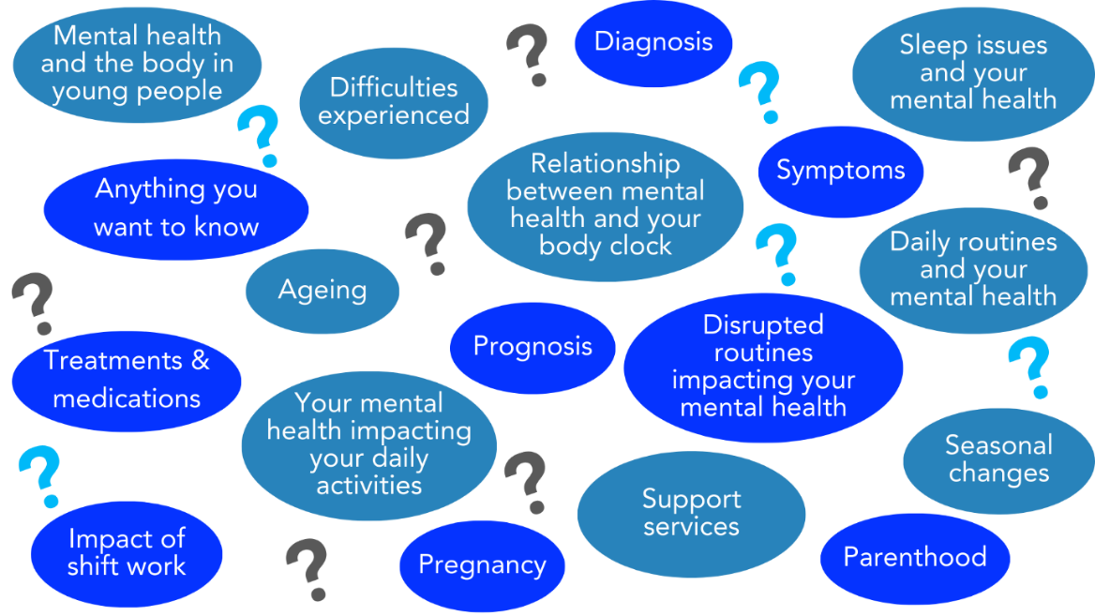

You can also complete the survey online here: https://forms.office.com/e/1SL5GjMPtt
Questions
1. Have you understood the information above, and do you consent to taking part in this survey?
If you need help understanding the information above, you are welcome to ask a parent, guardian, or carer to help you.
☐ Yes
☐ No
2. Do you live in the UK?
☐ Yes
☐ No
3. Do you have experience of:
Choose all that apply
☐ Mental health difficulties or a mental health condition?
☐ Disrupted body clocks (caused by shift work, jet lag, lifestyle)?
☐ Disrupted body clocks (such as sleep disturbances, sleeping when you should be awake and/or disruptions of your daily routine/activities)?
☐ Supporting individuals with mental health conditions or disrupted body clocks (are you family, a friend, a carer, a counsellor, a clinician, clinical support staff of people with experience of mental health conditions or disrupted body clocks)?
4. What would you like to know about how a disrupted body clock impacts on mental health?
Disrupted body clock could include sleep disturbances/problems, issues staying awake/aware, disruptions to daily routines, shift work, jet lag, seasonal changes, when the clocks go back/forward.... and many more.

5. What would you like to know about how mental health difficulties impacts the body clock (e.g., issues staying awake/alert)?

6. Do you have any questions about Mental Health and the Body Clock that you feel research needs to answer?
7. Do you have any further thoughts or experiences about Mental Health and the Body Clock you would like to share?

A bit about you
This next section asks for some information about you. This information will mainly be used to help us find out who we are reaching and hearing from, and who is being missed. However, we might also use summary information in our publications. This is anonymous, and we will not be able to identify you. We want to hear as many different voices as possible so that research in the future can help everyone.
You do not need to answer any question you are not comfortable with.
What is your age? (in years)
What County do you live in?
(For example, Aberdeenshire, Lanarkshire, Northumberland, West Midlands, Breconshire, Monmouthshire, Derry, Fermanagh etc.)

How would you describe your gender?
☐ Don’t know
☐ Prefer not to answer
How would you describe your sexual orientation?
☐ Don’t know
☐ Prefer not to answer
Do you identify as transgender?
☐ Yes
☐ No
☐ Don’t know
☐ Prefer not to answer
What is your ethnic group?
e.g., White British/Scottish/Welsh/English/Northern Irish, Black British, African, Caribbean, Pakistani, Bangladeshi, Chinese, Asian, Hispanic, Arab etc.
☐ Prefer not to answer
Do you consider yourself to have a disability or long-term health condition?
☐ Yes
☐ No
☐ Prefer not to answer
What level of education you have completed?
Choose all that apply
☐ Primary school
☐ Middle school
☐ Secondary/high school
☐ Trade/technical/vocational training
☐ Higher National Certificate/Degree
☐ Bachelor's degree
☐ Master's degree
☐ Professional degree
☐ Doctoral degree
What is your occupation?
If you are retired, please also include your previous occupation. If you are in school, please answer "School Student".
Are you a clinician?
If yes, please specify your area
☐ Yes
☐ No
Are you a carer of someone with a mental health difficulty?
☐ Yes
☐ No

Thank you for taking the time to complete our survey
Please send your completed survey back to us via the anonymous chat box on our website https://www.circadianmentalhealth.org/

You can follow this project on our website: https://www.circadianmentalhealth.org/
If this survey has caused you any discomfort or upset, you can reach out to the support organisations below.
Samaritans: https://www.samaritans.org/scotland/how-we-can-help/contact-samaritan/
Call: 116 123
Email: jo@samaritans.org
Papyrus : https://www.papyrus-uk.org/papyrus-HOPELINE247/ (for young people) Call: 0800 068 4141
Text: 07860039967
Email: pat@papyrus-uk.org
Shout: https://giveusashout.org/
Text "SHOUT" to 85258
Text "YM" to 85258 (for young people)
If you have any concerns about your mental health, please speak to your doctor/GP.

The National Institute for Health and Care Research (NIHR) funds the infrastructure of the James Lind Alliance (JLA) to oversee the processes for Priority Setting Partnerships (PSPs). PSPs aim to help patients, carers and clinicians work together to agree which are the most important evidence uncertainties affecting their particular interest, in order to influence the prioritisation of future research in that area.

